Test Report Document

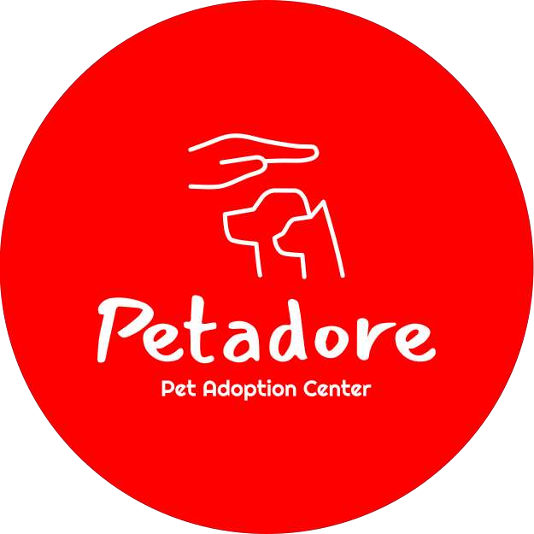

~ Ziyadatan Imad Aqil Mardi

Date: 20-03-2023

Last Updated: 09-06-2023

## Initial Requirements

- Connected to Cisco AnyConnect VPN (vdi.fhict.nl)

## Test Cases and Result

|  |  |  |  |  |  |
| --- | --- | --- | --- | --- | --- |
| ID | UC | Name | Pre-Condition | Test Data | Expected Result |
| TC-01 | UC-01 | Log in to desktop app | - | Username: mainadmin  Password: password | User logged in to application |
| TC-01  Result | User is able to log in | | | | |
| TC-02 | UC-01 | Log in to desktop application, wrong credentials | - | Username: example  Password: example | Validation Message pops up |
| TC-02  Result | Message Box pops up | | | | |
| TC-03 | UC-02 | Logs out of desktop application | User must be logged in | Click on the log out button and click on yes when confirming | User is sent back to Log in form |
| TC-03  Result | User is able to Log Out | | | | |
| TC-04 | UC-02 | Logs out of desktop application, cancelled | User must be logged in | Click on the log out button and click on no when confirming | Logging out is cancelled and the user remains logged in |
| TC-04  Result | User is not logged out | | | | |
| TC-05 | UC-03 | Add new cat | Must be in cats menu, on Add Cat tab | Name: Mittens  Age: 4  Gender: male  Shelter: Amsterdam Shelter  Description: (leave it blank or fill in anything) Breed: Ragdoll  Fur Color: Orange Allergies: Dust  Sterile: yes  Click Add Cat Button | Cat added. Message box shows confirmation |
| TC-05  Result | Cat added after refreshing | | | | |
| TC-06 | UC-03 | Validation check | Must be in cats menu, on Add Cat tab | Leave the Name, fur color, or allergies textboxes blank | Message Box validation appears. Cat is not added |
| TC-06  Result | Message box pops up, cat is not added | | | | |
| TC-07 | UC-04 | Remove Cat | Must be in cats menu, on Available Cats tab | Click on Delete button on one of the animal user control, click on “Yes” in the confirmation Message Box and then click on Refresh | Cat is deleted. Once user refreshes, the cat no longer is in the list |
| TC-07  Result | Cat is removed after refreshing | | | | |
| TC-08 | UC-04 | Cancels Remove Cat | Must be in cats menu, on Available Cats tab | Click on Delete button on one of the animal user control, click on “No” in the confirmation Message Box | Cat is not deleted. Once user refreshes, the cat remains in the list |
| TC-08  Result | Cat is not removed | | | | |
| TC-09 | UC-05 | View Cat Information | Must be in cats menu, on Available Cats tab | Click on Modify button | A new form will pop up with all the data of the selected cat |
| TC-09  Result | Cat information is shown in the modify form | | | | |
| TC-10 | UC-06 | Edit Cat | Must be in cats menu, on Available Cats tab | Click on Modify button, change the desired data and click Modify Cat | Cat data is modified, Once user refreshes, the new data will be shown in the list |
| TC-10  Result | Cat is modified | | | | |
| TC-11 | UC-06 | Edit Cat Validation | Must be on the Modify Cat form | Leave the Name, fur color, or allergies textboxes blank | Message Box validation appears. Cat is not modified |
| TC-11  Result | Message Box pops up, cat is not modified | | | | |
| TC-12 | UC-07 | Add new shelter | Must be in shelters menu | Name: Arnhem Shelter  Location: Arnhem  Address: Vesuviuslaan 21  Click Add Shelter Button | Shelter added. Message box shows confirmation |
| TC-12  Result | Shelter added after refreshing | | | | |
| TC-13 | UC-07 | Validation check | Must be in shelters menu | Leave the any textboxes empty | Message Box validation appears. Shelter is not added |
| TC-13  Result | Message box pops up, shelter is not added | | | | |
| TC-14 | UC-08 | Remove Shelter | Must be in shelters menu | Click on Delete button on one of the shelter user control, click on “Yes” in the confirmation Message Box and then click on Refresh | Shelter is deleted. Once user refreshes, the shelter no longer is in the list |
| TC-14  Result | Shelter is removed after refreshing | | | | |
| TC-15 | UC-08 | Cancels Remove Shelter | Must be in shelters menu | Click on Delete button on one of the shelter user control, click on “No” in the confirmation Message Box | Shelter is not deleted. Once user refreshes, the shelter remains in the list |
| TC-15  Result | Shelter is not removed | | | | |
| TC-16 | UC-09 | View Shelter Information | Must be in shelters menu |  | Each user control shows the full detail of the shelter |
| TC-16  Result | Shelter information is shown in the user control | | | | |
| TC-17 | UC-10 | Edit Shelter | Must be in shelters menu | Click on Modify button, change the desired data and click Modify Shelter | Shelter data is modified, Once user refreshes, the new data will be shown in the list |
| TC-17  Result | Shelter data is modified | | | | |
| TC-18 | UC-10 | Edit Shelter Validation | Must be on Modify Shelter form | Leave the any textboxes empty | Message Box validation appears. Shelter is not modified |
| TC-18  Result | Message Box pops up, shelter data is not modified | | | | |
| TC-19 | UC-11 | View Adoption requests | Must be in adoptions menu | Click on details | Adoption details will be shown in a Message Box |
| TC-19  Result | Adoption details is shown on message box | | | | |
| TC-20 | UC-11 | No Adoption Requests | Must be in adoptions menu |  | Adoption requests layout panel remains empty |
| TC-20  Result | When no requests, the layout panel is empty | | | | |
| TC-21 | UC-12 | Declines adoption request | Must be in adoptions menu | User clicks on decline adoption and then refresh | Request is deleted |
| TC-21  Result | Request is removed after refreshing | | | | |
| TC-22 | UC-13 | Accepts adoption request | Must be in adoptions menu | User clicks on accept adoption and then refresh | All adoption request with the requested animal is deleted and the requester id is binded to the animal |
| TC-22  Result | Request, and requests with the same animal are removed after refreshing | | | | |
| TC-23 | UC-14 | Registering Account | Must open Website and navigate to Register page under the Login form or from the carrousel | **Email:** [sample@email.com](mailto:sample@email.com)  **Username:**  SampleUser  **Password:**  SamplePass  **Confirm Password:**  SamplePass  **Firstname:** Ali  **Lastname:**  Baba  **Address:**  Keukenlijn 83, Amstelveen  **Birthdate:**  1999-07-10 | Redirected to Login page |
| TC-23  Result | User is redirected to login page | | | | |
| TC-24 | UC-14 | Register with wrong parameters | Must open Website and navigate to Register page under the Login form or from the carrousel | Leave any empty | Alert message will show |
| TC-24  Result | Registration is not completed | | | | |
| TC-25 | UC-15 | Log in to website | Must open Website and navigate to Login page on the top menu | Username: SampleUser  Password: SamplePass | Redirected to Index page |
| TC-25  Result | User is able to login to website | | | | |
| TC-26 | UC-15 | Log in with wrong credentials | Must open Website and navigate to Login page on the top menu | Username: sample  Password: sample | Error Message shows |
| TC-26  Result | Alert message shows up on top of page | | | | |
| TC-27 | UC-16 | User searches animal by name | Must open Website and navigate to Find a pet page on the top menu | Search By: name Search term: Tony | Animals that contains the word in their name will show |
| TC-27  Result | Animal with the name is shown | | | | |
| TC-28 | UC-16 | User searches animal by name, not found | Must open Website and navigate to Find a pet page on the top menu | Search By: name  Search term: (random words) | Website shows nothing |
| TC-28  Result | No animals shown | | | | |
| TC-29 | UC-17 | User searches animal by shelter | Must open Website and navigate to Find a pet page on the top menu | Search By: shelter  Search term: Utrecht | Animals that contains the word in their shelter’s name will show |
| TC-29  Result | Animal with the shelter’s name are shown | | | | |
| TC-30 | UC-17 | User searches animal by shelter, not found | Must open Website and navigate to Find a pet page on the top menu | Search By: shelter  Search term: (random words) | Website shows nothing |
| TC-30  Result | No animals shown | | | | |
| TC-31 | UC-18 | User searches animal by species | Must open Website and navigate to Find a pet page on the top menu | Species filter: dog  Search By: name  Search term: Maverick | Animals with specified criteria will show |
| TC-31  Result | Animal with specified criteria shown | | | | |
| TC-32 | UC-18 | User searches animal by species, not found | Must open Website and navigate to Find a pet page on the top menu | Species filter: cat  Search By: name  Search term: Maverick | Website shows nothing |
| TC-32  Result | No Animal shown | | | | |
| TC-33 | UC-19 | User views animal’s details | Must be logged in, Must open Website and navigate to Find a pet page on the top menu | Click on view button on the animal’s card | Redirect to animals details page |
| TC-33  Result | User is able to see animal’s details | | | | |
| TC-34 | UC-20 | User view available shelters | Must open Website and navigate to Shelter page on the top menu | Click on Shelter menu on the navigation bar | Redirect to Shelter page, shows available shelters |
| TC-34  Result | User is able to see available shelters | | | | |
| TC-35 | UC-21 | User searches shelter | Must open Website and navigate to Shelter page on the top menu | Search term: Noord | Shelter that contains the word in its data will show up |
| TC-35  Result | Shelter that contains the search term are shown | | | | |
| TC-36 | UC-21 | User searches shelter, not found | Must open Website and navigate to Shelter page on the top menu | Search term: Zuid | Website shows nothing |
| TC-36  Result | No shelter shown | | | | |
| TC-37 | UC-22 | User uses advanced Filter search | Must open Website and navigate to Advanced Filter page by going through find a pet page under the search bar | Species : dog  Gender: male  Minimum age: 0  Maximum age: 5  Breed: Labrador  Activity Level: low  Housetrained: check  Sterile: check | Website shows animal with desired criteria |
| TC-37  Result | Animal with specified criteria are shown | | | | |
| TC-38 | UC-22 | User uses advanced Filter search, No match found | Must open Website and navigate to Advanced Filter page by going through find a pet page under the search bar | empty | Website shows nothing |
| TC-38  Result | No animal shown | | | | |
| TC-39 | UC-23 | User requests to adopt animal | Must be logged in, Must open animal details page | Click on adopt animal and confirm by clicking on yes | Redirects to thank you page, request is sent to the desktop application |
| TC-39  Result | Message box pops up, and redirected to a thank you page | | | | |
| TC-40 | UC-23 | User cancel adoption request | Must be logged in,  Must open animal details page | Click on adopt animal and confirm by clicking on no | Website does nothing |
| TC-40  Result | Adoption cancelled, goes back to animal details page | | | | |